CHAPTER ONE
A BUSINESS MARKETING PERSPECTIVE

Business Markets
Market for products and Service
Local to international - Bought by:
- Businesses
- Government bodies
- Institutions
  - For consumption
  - For use
  - For resale
A Market Driven Firm
Has:
- Market sensing capability … companies ability to sense change and to anticipate customer responses.
- Customer linking … the ability to develop and manage close customer relationships.
Marketing’s Cross Functional Relationship
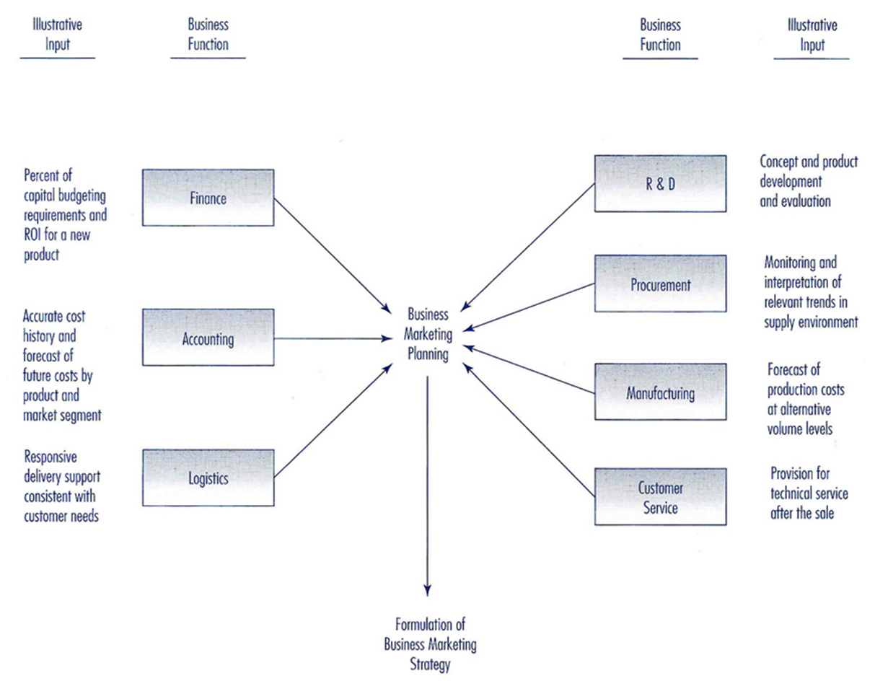
Business marketing planning must be coordinated and synchronized with corresponding planning efforts.
Keys to Cross Functional Working Relationships
- Communications
- Perspective taking
- Responsive behavior
- Compatibility
Business Market Characteristics
- Derived demand
- Fluctuating demand
- Stimulating demand
- Price sensitivity/demand elasticity
- Global Market perspective
Relationship Marketing
All marketing activities directed toward establishing, developing, and maintaining successful exchanges with customers.
The Supply Chain
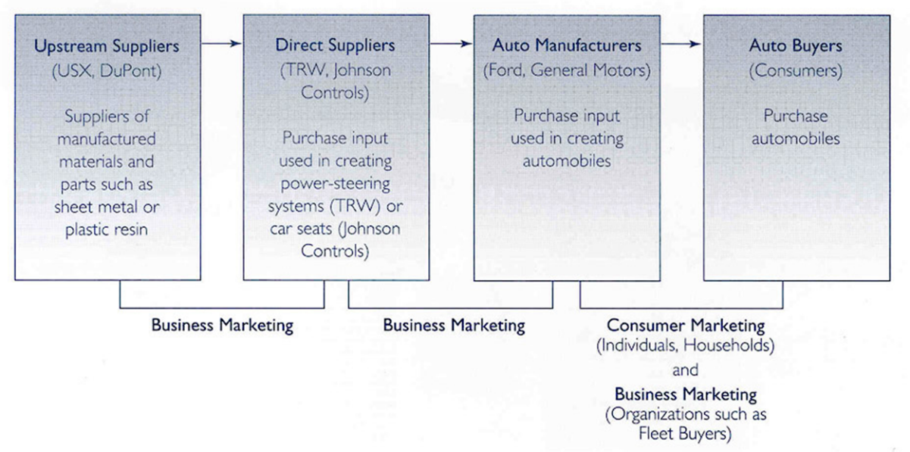
Michael Porter and Victor Millar observed that “to gain competitive advantage over its rivals, a company must either perform these activities at a lower cost or perform them in a way that leads to differentiation and a premium (more value).”
Procurement Trends
- Longer Term and Closer Relationship
- Closer Interactions among multiple functions
- Supplier proximity considerations
Business Market Customer Commercial Enterprises
- Users
- OEMs
- Dealers and Distributors
Classifying Goods for The Business market
Classifying industrial goods by the following questions:
- How does the good or service enter the production process?
- How does it enter the cost structure of the firm?
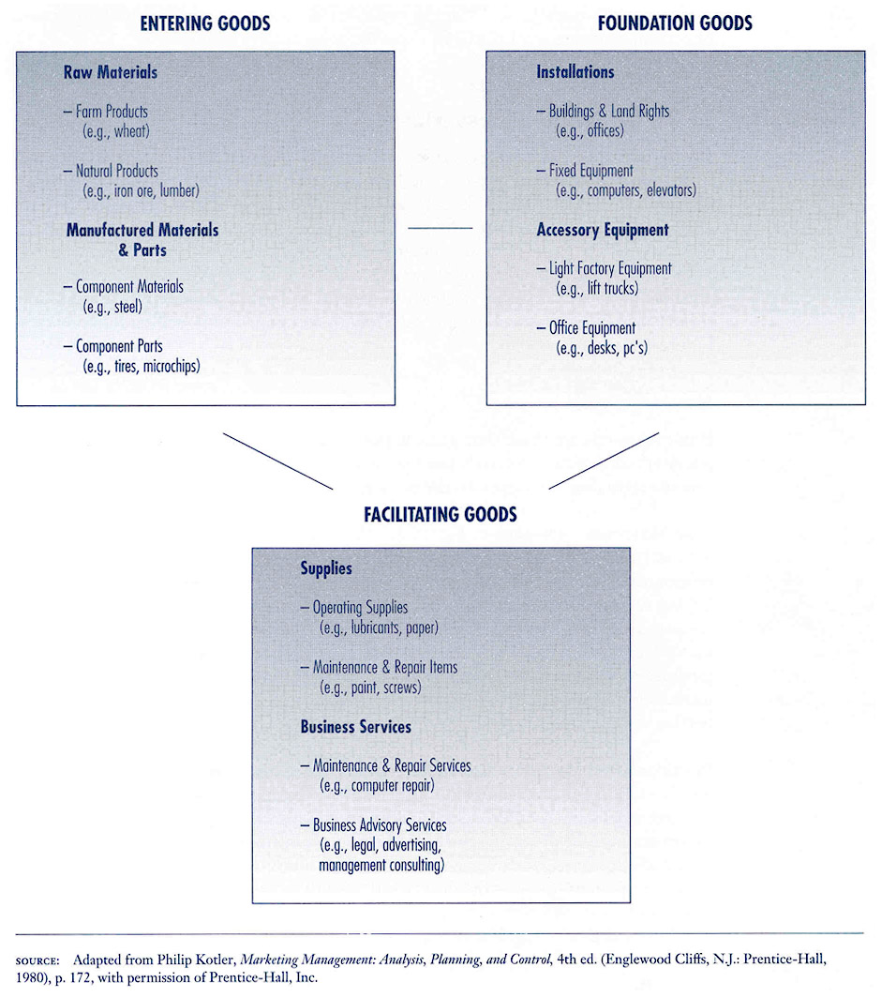

A Framework for Business Marketing Management
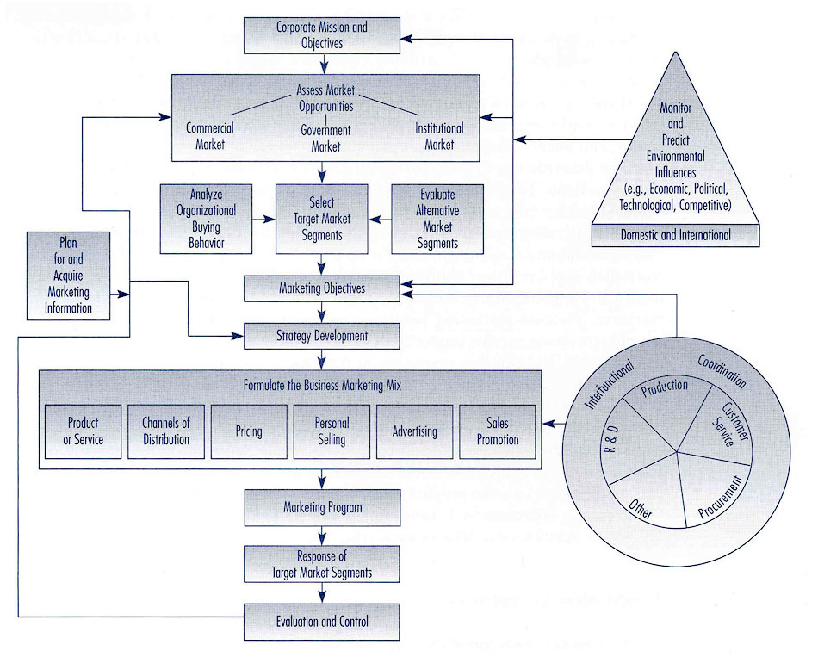
Business marketing strategy is formulated within the boundaries established by the corporate mission and objectives.
Source:
Business Marketing management 8th edition, Michael D.Hutt, Thomas W. Speh

