CHAPTER TWO
PERSPECTIVES ON THE ORGANIZATIONAL BUYER

Manufacturers & Geographics
- Half are located in eight states
- Important implications:
- First, can concentrate marketing efforts
- Second, with distribution centers in large volume areas rapid delivery is possible
- Third, sales personnel may not be tied to specific geographic areas

Classifying Commercial Enterprises
- NAICS organizes business activity into economic sectors and identifies groups of business firms that use similar production processes.
- Result of NAFTA.
- Replaces SIC system.

North American Industrial Classification System
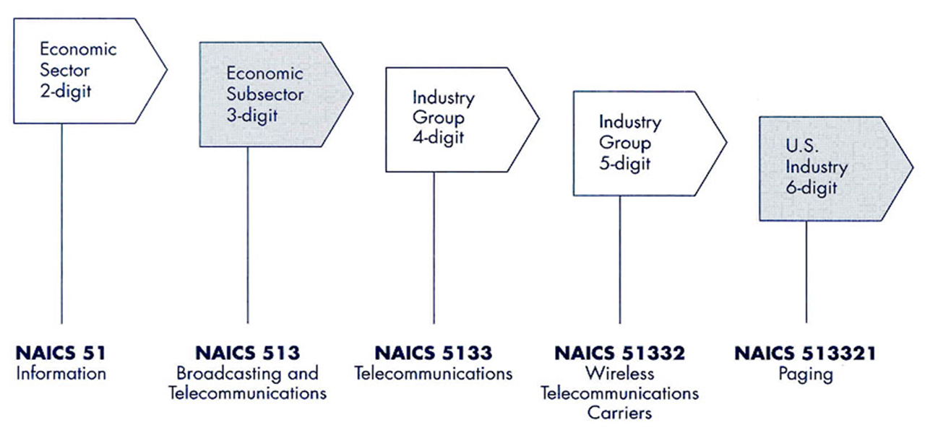

Purchasing Function Goals
- To address the needs of business customers of all types.
- May have to juggle a number of different objectives that clash.

The Goals of Purchasing:
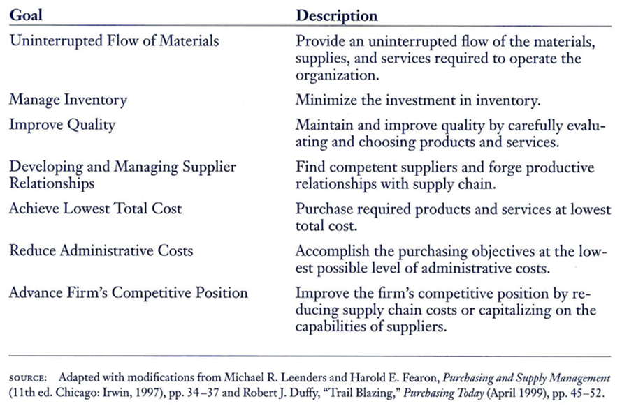

Total Cost Considerations of a Product or Service
- Factors that drive total cost.
- Acquiring and managing costs.
- Quality, reliability over the life cycle.
- The value a firm/ customers.

Levels of Procurement Development and Pathways to Savings/Revenue Enhancement
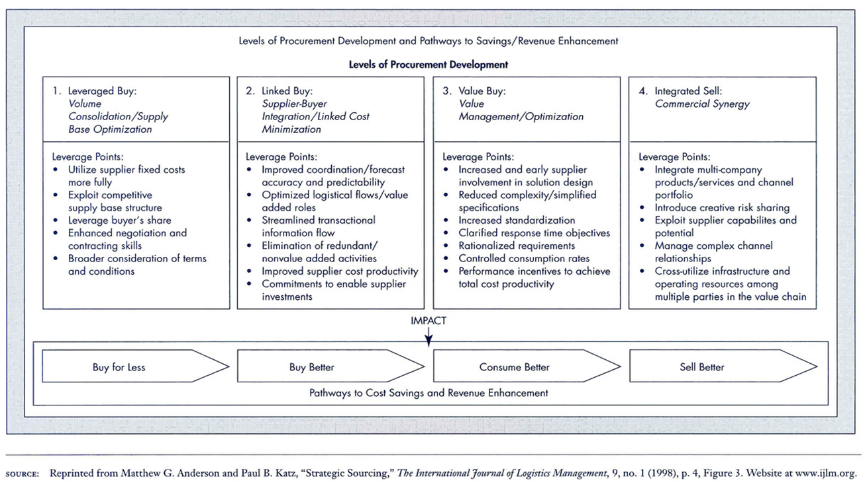

Segmenting Purchase Categories
1st Point, each firm has a unique portfolio.
2nd Point, more attention on purchases having the greatest impact on revenue generation or the greatest risk to performance.

Segmenting the Buy:
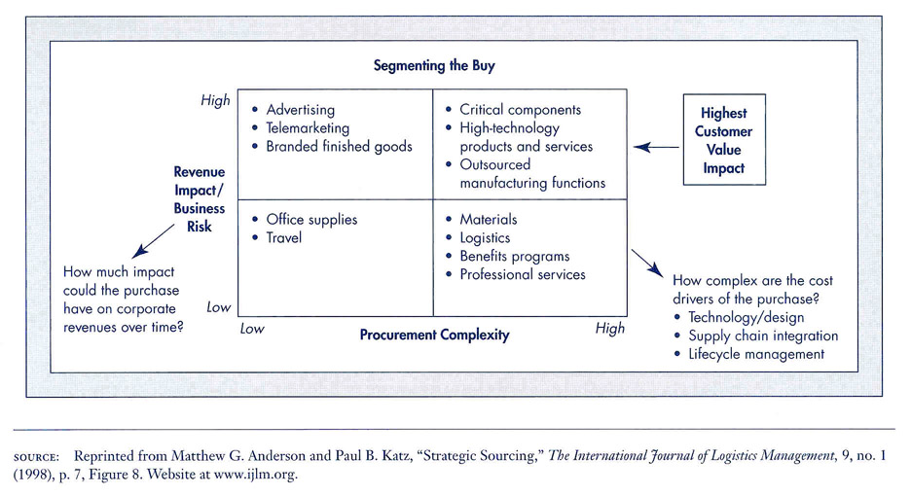

Procurement Complexity Considerations
- Technical complexity.
- Scope of supply chain coordination required.
- Degree to which life cycle costs are relevant.
Purchasing Managers & Performance
The Weighted –Point Plan
- The buying organization weights each performance factor.
- Organization assigns relative importance to performance factors.
- Is more objective and flexible than the categorical method.
Government Contracts “Programs”
- Compliance, requires government contractors maintain affirmative action programs.
- Set-aside, a percentage of the contract is set aside for small minority businesses.
- Minority, subcontracting- may require major contractors subcontract a certain percentage of the contract to minority firms.
Two Types of Contracts
- Fixed-price contracts
  - A price is agreed to before contract is awarded and payment is made at conclusion of work.
  - Provides for the greatest profit potential.
  - Poses greater risks.
- Cost-reimbursement contracts
  - Reimbursement for allowable costs may be allowed and sometimes a number of dollars above costs as profit is allowed.
Government Procurement
- Defense-said to be the largest enterprise in the world (DOD).
- Nondefense-procurement is administered by world wide variety of agencies.

Two Procurement Strategies
- Formal Advertising—the government solicits bids from suppliers, and usually the lowest bidder is awarded the contract.
- Negotiated Contract—used to purchase products or services that are not differentiated on price alone, competition is common.
Source:
Business Marketing management 8th edition, Michael D.Hutt, Thomas W. Speh

